
Havens Health Surgery
Patient Newsletter – February 2026

We’re changing the ways you can request appointments with our Clinical Team

As you may already know, all surgeries across the country have been encouraged to improve their online access for requesting GP appointments.

Therefore, from Monday 2nd February 2026, and in line with NHS guidance, we’re improving the ways in which our patients can request appointments with our GP Team.

From that date, we will be encouraging patients to make their appointment requests and clinical queries via an online consultation form on our website at www.havenshealth.co.uk.

A GP here will review requests and decide on the most appropriate care - be that a same-day or less urgent appointment, phone call, or another service.


Why are we making this change?

This change ensures everyone gets a safer service as clinical requests will be screened promptly by a GP as they come through. Appointments will be allocated based on clinical need, not on just who calls first.
The Triage GP may be able to deal with some queries as they come through straight away - without a formal appointment.

They can also redirect some queries to other professionals better placed to manage them eg. Pharmacists or Physiotherapists.

We understand that you may have some questions about how these changes will affect you and so we’ve tried to answer some of those questions in this leaflet.
How do I request an appointment?
If your request is not a medical emergency (see examples below), go to our practice website at www.havenshealth.co.uk and click on our “Submit a new request” as shown here
(This will also be accessible via the NHS App in the future.)

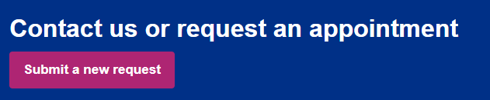

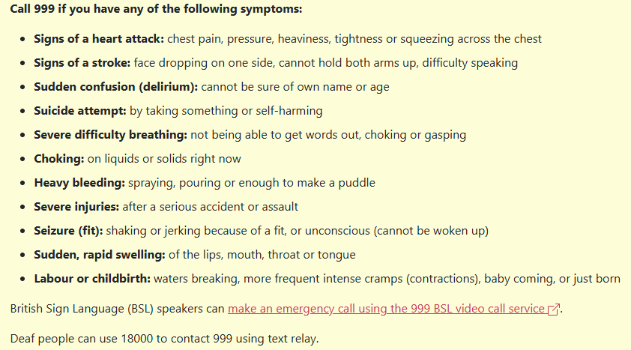

Between 6.30am and 4.30pm, Monday to Friday, you can use this service for:

- Requesting a Non-Emergency appointment with a GP
- Medication queries and requests
- Asking for Test Results
- Requests for Fit Notes (Sick notes)

Outside of these times, you will still be able to contact us in the usual way either by telephone, via our website ‘contact us’ form or at the Front Desk.

We would advise patients to use the online forms whenever possible, to allow the phone lines to be freed up for those patients who cannot use online methods.

What if I can’t use the internet or need help?
Don’t worry. Patients who cannot go online or need help can still:

- Telephone the surgery – if appropriate, our team will fill in the online form on your behalf
- Ask a friend or family member to complete it for you (with your consent)
- Come into the surgery and speak with one of our receptionists

Will I still be able to see a doctor or nurse face-to-face?
Yes. If the clinical team decides a face-to-face appointment is needed, you will be offered one. The online form simply helps us decide the best first step.

For appointments, you may receive a call from the reception team to book this in or you may be sent a self-book link to choose a date and time that suits you.

When will I get a response?
For clinical queries sent using the forms between 6.30am and 4.30pm, Monday to Friday, your request will be assessed by a clinician on the same day or next day at the latest. Most patients will receive a response from the surgery the same day. We will let you know

what will happen next or what the outcome is.

What about home visits?
These will still be arranged based on clinical need, especially for housebound or vulnerable patients. Use the online form (or call us) to request help, as early in the day as possible.

Will I still be able to see my regular GP?
Yes. We recognise the value in seeing a regular clinician, particularly for routine appointments and complex clinical issues.
The online form allows you to specify a particular clinician you feel would be best placed to deal with your issue, and where possible, we will try to accommodate this as we currently do.
However, for urgent care requiring an appointment very soon, it may not be possible for you to see your regular GP if they are not available, and it may not be safe for you to wait until they are available - the priority here will be providing urgent clinical assessment by a trained clinician as soon as possible.

What do I do to book a Nurse Appointment?

The booking of appointments with our Nursing and Health Care Assistant team will stay exactly as it is for now.

We will be making some improvements to this process as we go through the coming months.

Finally….
We are genuinely excited at this positive change to the way that we work and the great benefits it will have for our patients.
Please bear with us over the coming weeks as we start to implement the process and identify areas where changes need to be made to improve our patient experience.

Any questions…? Let us know! Use the contact form on our website or call us.

